Comparison of SNF, NNF and PNF in 0LN and 0MN models 9/27/2021

Parameters in auxiliary feedback loops are searched with the constraints as shown below

* Average Bmal matches SNF, relative amplitude of Bmal~0.2
* Rhythmicity features (average, amplitude, period) of Ptot matches SNF

1. SNF 0LN model

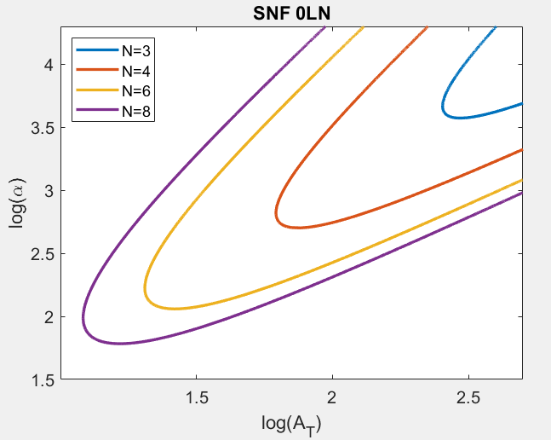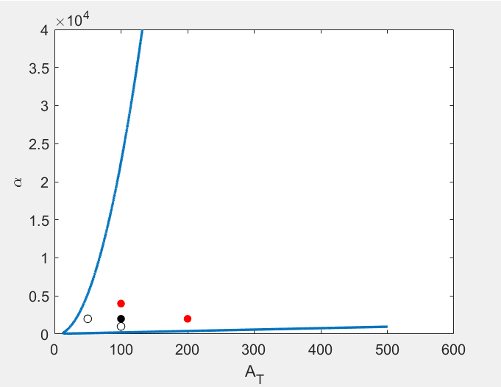

*Black circle* corresponds to the default At-alpha value for homozygous diploid, which is

At=100, alpha=2,000

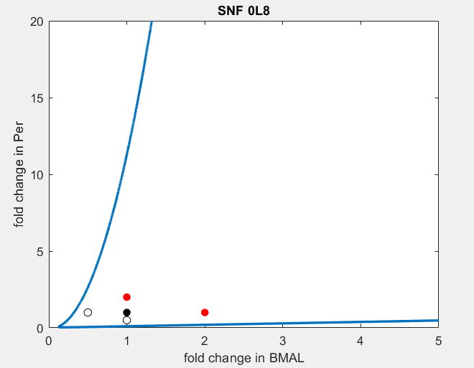

2. NNF 0L8

delta= 0.26, Amax=118, Vmax=1.5

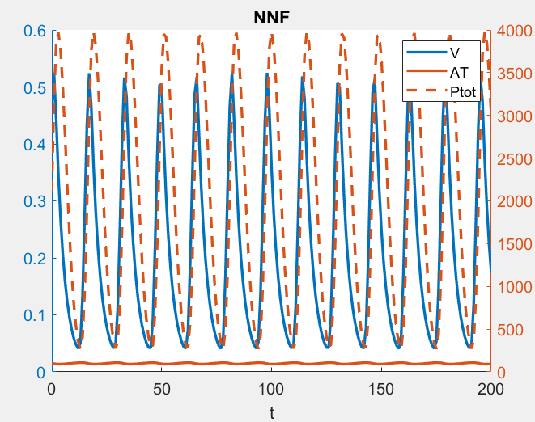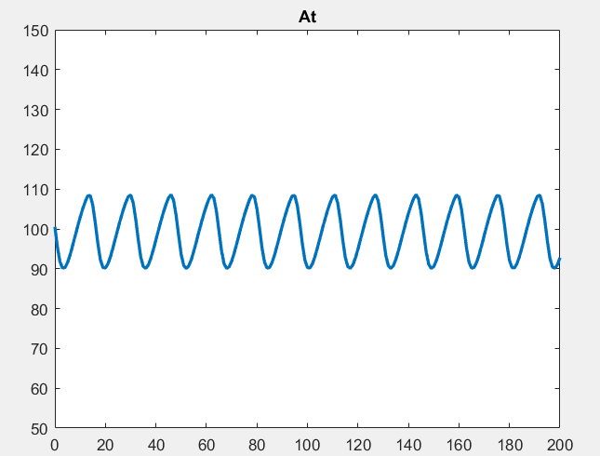

average(At) ~ 100, relative amplitude is ~0.2, period ~16, which are consistent with SNF 0L8.

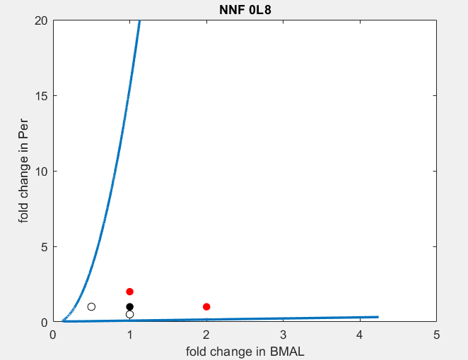

Default Amax=118, alpha=2,000

3. PNF 0L8

delta= 0.12, Amax=228, Rmax=6.3

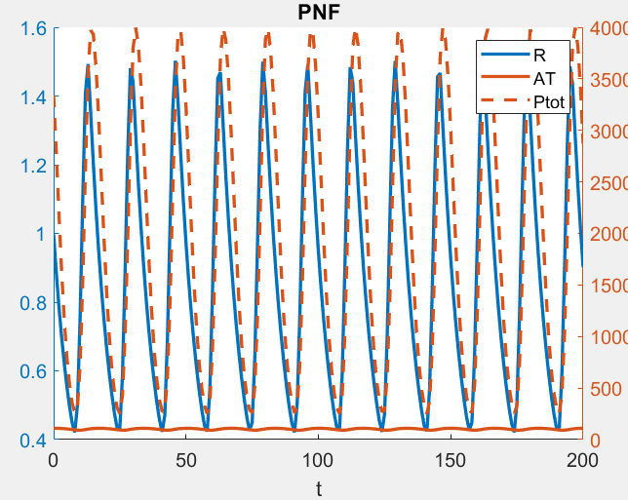 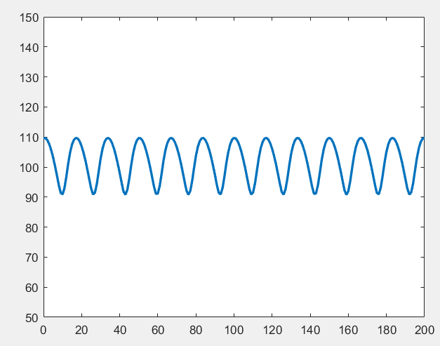

avg(At)~ 100, max(Ptot)~4,000, period(Ptot)~16

Default Amax=228, alpha=2,000

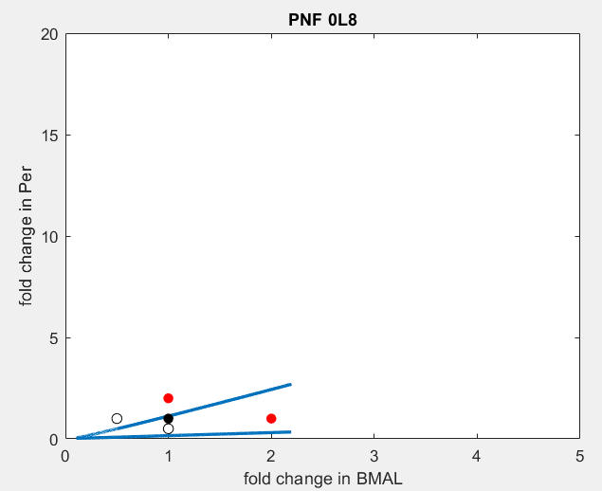

Overlay of SNF, NNF and PNF

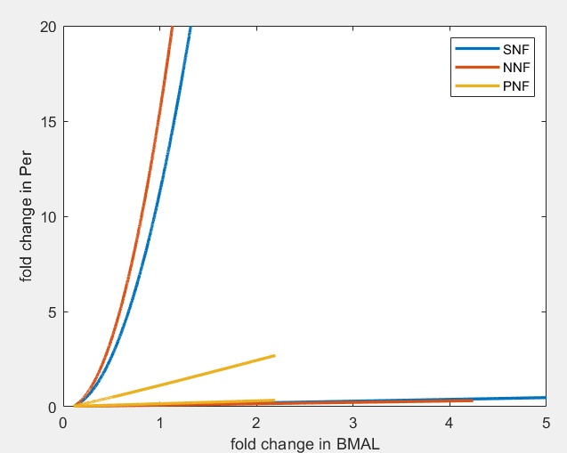

(1,1) corresponds to the default expression of Bmal and Per for different models

SNF 0M8

Km = 1, beta=3.8

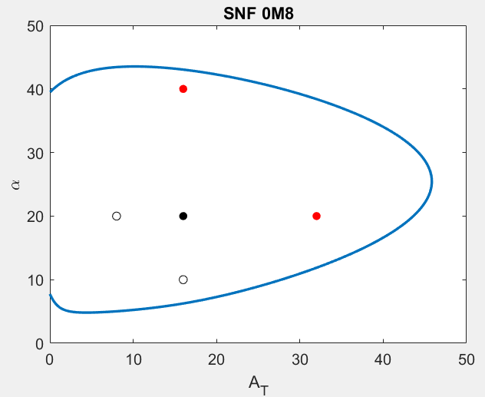 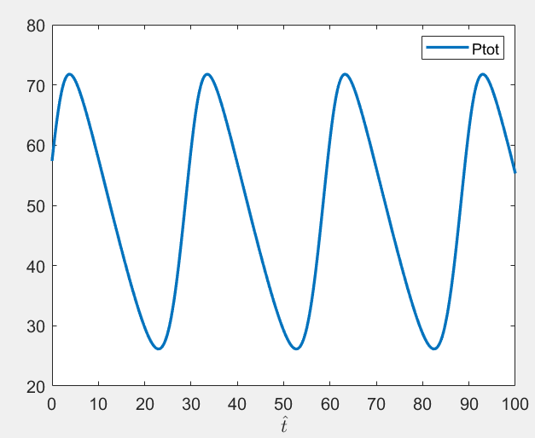

At=16, alpha=20,

max(Ptot)~75, period(Ptot)~30

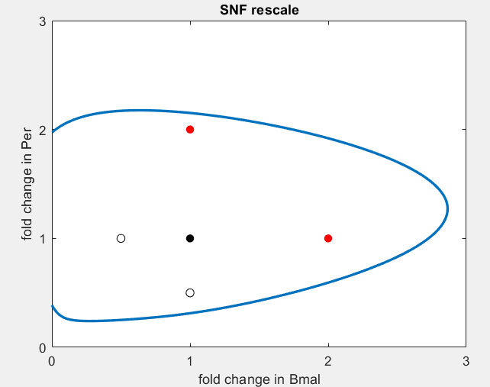

NNF

delta= 0.06, Amax=114, Vmax=38

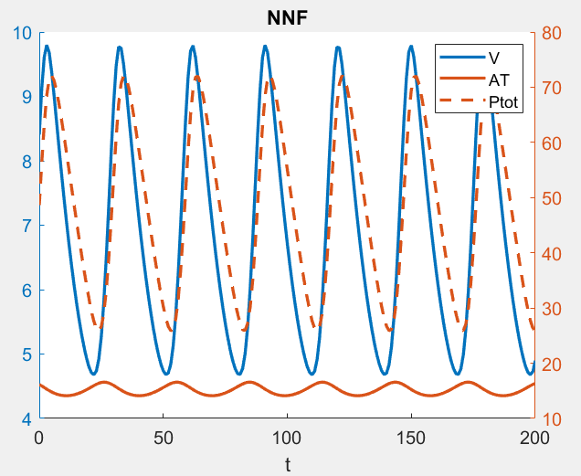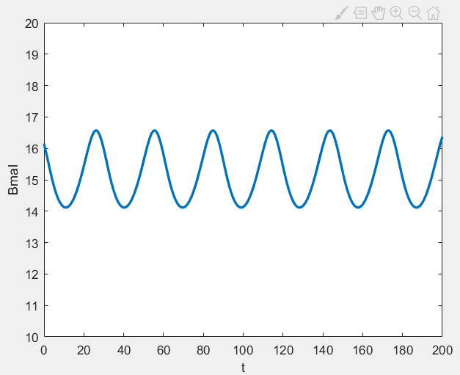

avg(Bmal)~16,

max(Ptot)~75, period(Ptot)~30

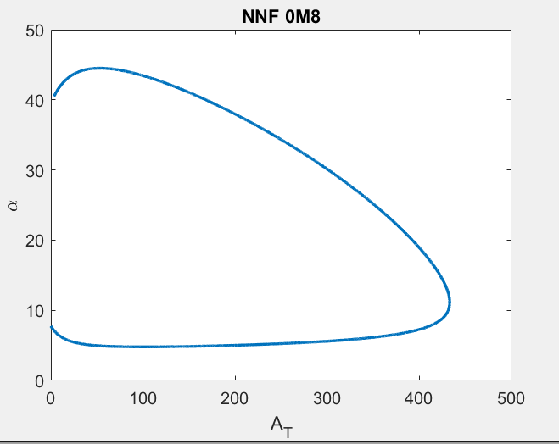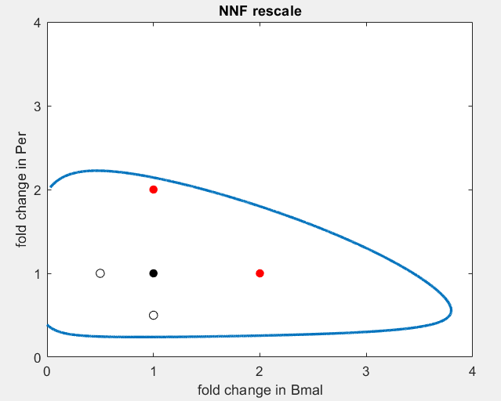

PNF

delta= 0.1, Amax=25, Rmax=11

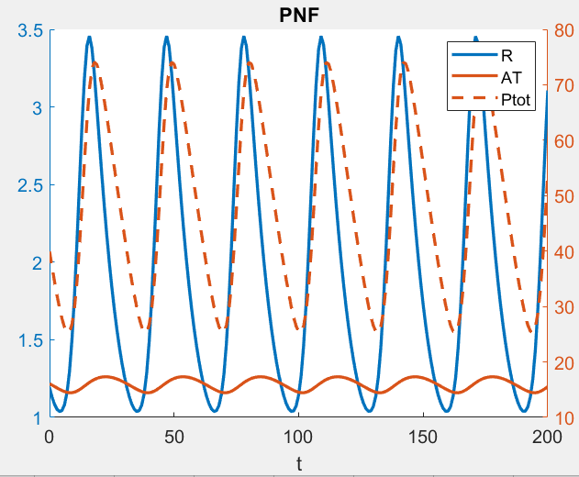

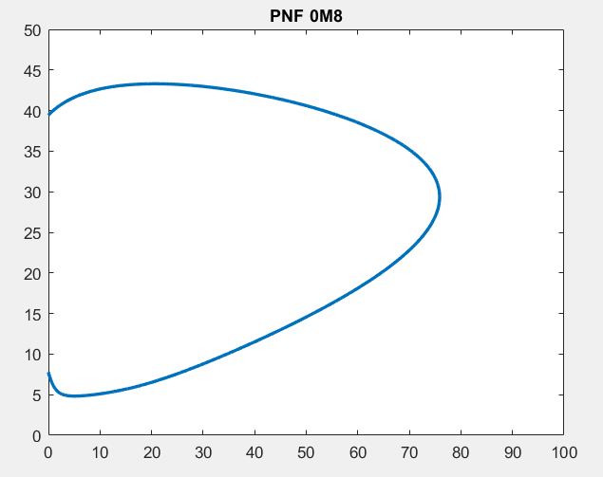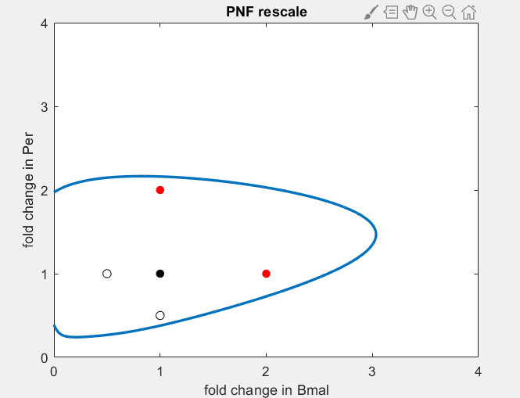

Overlay of fold-change of Bmal-Per unscaled Vs scaled.

